Info for coaches on booking RFU courses

To book a coaching course you have to be a member of englandrugby.com. Once signed up

login to www.englandrugby.com and click My Rugby tab

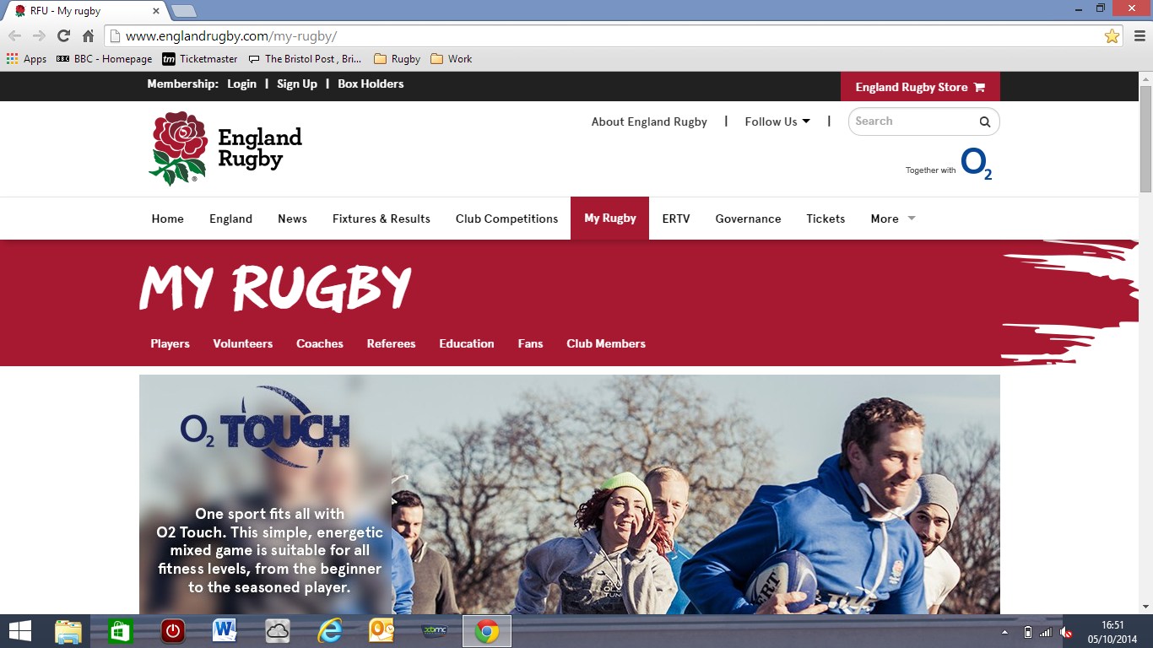

Scroll down to Coaches and click on the tab.

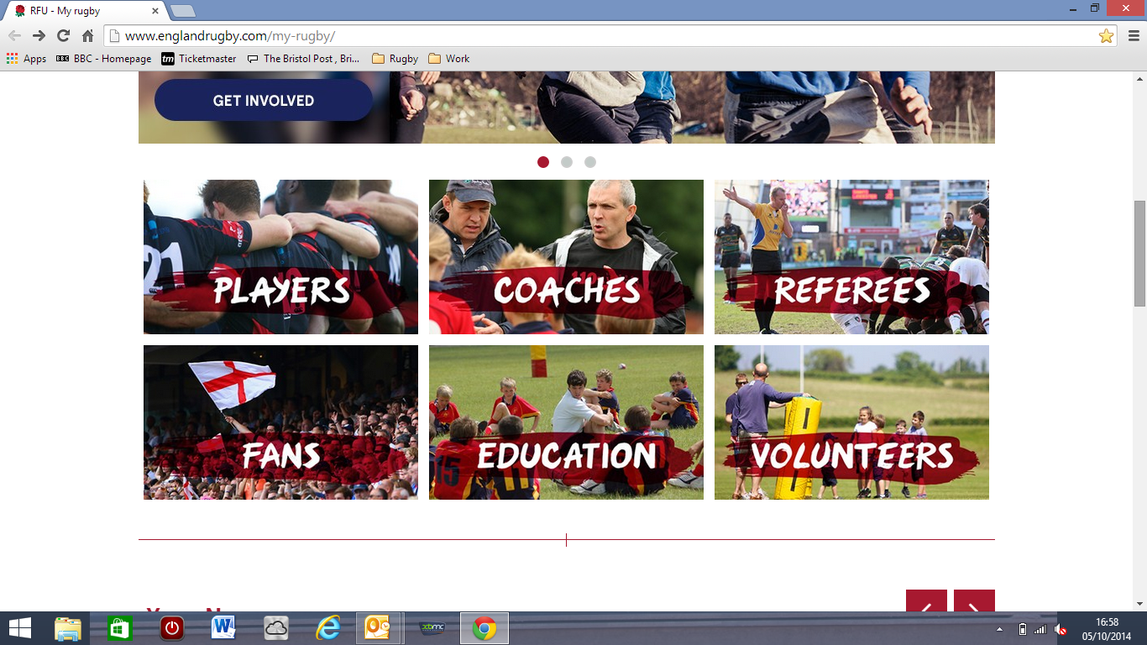

Scroll down to online course booking and click the hyperlink

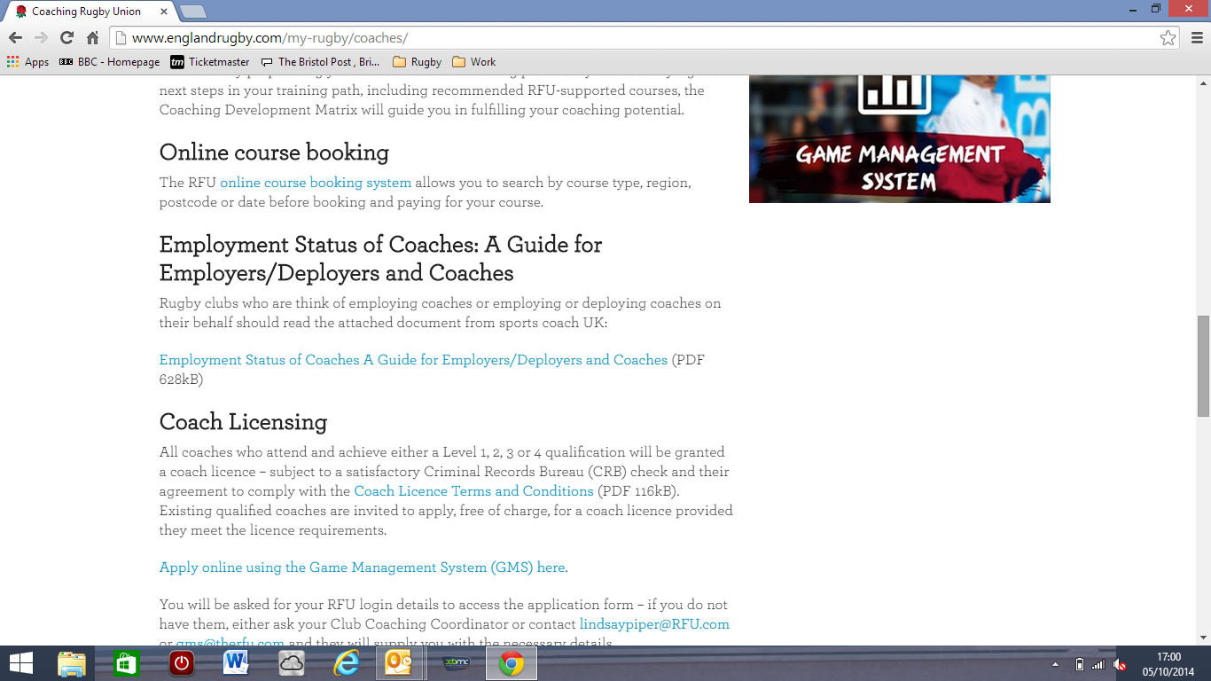

From here search the type of course you want, within the time frame you want

